User Guidelines
Of
“Support Shared Hardwares”
In ProTouch
(Multi-Client Application)

Prepared
For
Tellix AS

By
Dipesh

Revisions | Date | Description
1.0 | 3-August-2017 | Version 1.2.6.0 (Small application to manage databases and licenses)
1.1 | 3-October-2017 | Version 1.2.8.0 (Set the multi-client flag and functionality to remove database/license)
1.2 | 28-September-2018 | Steps to configure multi clients in existing ProTouch running customer machine. Reference: 1.1 -> (1).

Contents
1 Introduction 3
1.1 Overview 3
1.2 References 3
1.3 Conclusion 4
2 Multi Clients application 5
2.1 Manage Database(s) Page 5
2.1.1 Set Multi Client Mode 5
2.1.2 Add New Database to create 6
2.1.3 Create Database(s) 6
2.1.4 View already created databases 6
2.1.5 Delete/Remove database from machine 6
2.1.6 Other 6
2.2 Manage License(s) Page 7
2.2.1 Add New License to create 7
2.2.2 Save License(s) 7
2.2.3 Other 7
2.3 View Licenses Page 8
2.3.1 View already registered licenses 8
2.3.2 Delete/Remove license from machine registry 8
3 End Users related functionality (Client Application) 9
3.1 User Interfaces 9

Introduction

Overview
- Existing clients also can use this functionality. Steps are configuration are as following:
  - Existing Customers: Already installed (running) ProTouch application must be successfully updated to latest available version through auto update.
  - New Customers: New customers’ POS must be configured with POS key in SA web app.
  - Multi Clients Application: User need to set the Multi Client flag to ON. User can see the already created databases so need to configure the licenses for already using customers.
  - Multi Clients Application: User need to create the databases for new customers by browsing the database SQL script of latest database version, which the existing running application is using. Panteon will provide the latest SQL script, as currently they are not available on download server http://download.tellix.no/. In future, SQL script files of all version will be available on download server.
  - Multi Clients Application: After creating databases, user need to configure the license for new customer.
  - User need to make sure that all databases and licenses of all customers which are going to use multi clients machines must be properly configured before starting the ProTouch client application.
  - After all the customers’ databases & licenses are properly configured through “Multi Clients Application” then user need to start the ProTouch application and first select the newly configured customers one by one to perform full sync.
  - Once the full sync of all newly customers is successfully finished for all the newly configured customers, User can start to use the ProTouch application as normally and can use “Switch Clients” functionality.
- To support shared hardware across clients/departments there should be different databases for each client/department‘s POS in local SQL server 2012 express.
- This functionality will allow switching between
  - Multiple POS of different/same Clients
  - Multiple POS of same Departments
  - Multiple POS of different Departments of same Client
- Mac Id (POS unique key) will be same for all POS of multi clients.
- IsMultiClient mode needs to be set through Multi Client application.
- Client application will decide whether to run as normal mode or multi clients mode based on this flag’s value.
- In application folder, there will be text file called “MultiClient.txt” which is used to identify to start POS of selected department.
- Background data sync behavior remains same as the application runs in normal mode.
- It is mandatory to configure databases and licenses for different clients/departments through “Multi Clients” application.
- Following entities’ data sync from server will performed(if there any updates) when each client/department’s user switches/starts first time in a day:
  - Users and Permissions
  - POS modules
  - Client, Department and POS details
  - Products and Tiles
  - Rooms and Tables (If module is active)
- Auto update will performed for all clients/departments irrespective of any department/client’s user is performing auto update. Means if there is any SQL script in auto update then it will executed for all databases for all clients/departments during auto update.
- App Log file will be same for all clients/departments in application folder. There is client, department and POS details in app log to identify logs of specific client/department/POS in case of switch clients.

References
GitHub Issues:
#70: Support shared hardware across clients
#136: Create application to install/uninstall multi licenses in same hardware

Conclusion
Following things are required to use “shared hardware across clients” functionality
- User needs to create clients, departments, POS and licenses through SA web app.
- IsMultiClient parameter needs to be set through “Multi Clients” application.
- Configuration of databases and licenses done through “Multi Clients” application.

Multi Clients application
It is a small application to configure licenses and databases for different clients/departments who will use the client application.
Only Tellix AS can use this application.
It is recommended to first configure Multi Client mode through application.
After that, User need to configure SQL server connection related parameters in “appSettings” section in “ProTouchMultiClients.exe.config” file.

Manage Database(s) Page
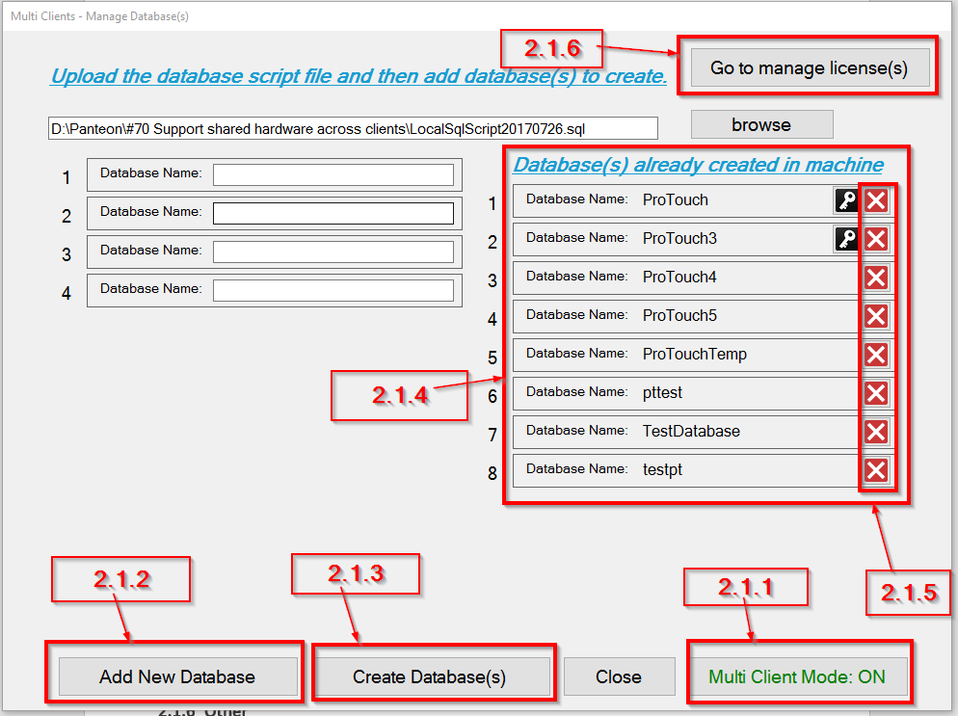

Set Multi Client Mode
- User can see the Multi Client flag value at bottom right button.
- User can set the Multi Client mode flag value to ON/OFF by clicking the button.

Add New Database to create
- User needs to browse latest ProTouch create database SQL script file.
- Then click on “Add New Database” button to add the number of inputs to create databases.
- Go to Requirement 2.1.3

Create Database(s)
- User needs to enter proper database names to create in SQL Server (specified in app.config).
for ex. ProTouch_DepartmentName_PosNumber (ProTouch_Tellix_10005)
- After entering proper database name(s), user need to click on “Create Database(s)” button to create entered database(s) in SQL server.
- If database(s) successfully created then application will display successful alert else display error message box.
- If database created successfully then user can proceeds to manage licenses. (Go to Requirement 2.2)

View already created databases
- User can see already created database names in “Created Databases” panel.
- There is key icon next to database name if database is associated with license key.

Delete/Remove database from machine
- User can delete/remove the database from machine by clicking delete icon next to database name.
- User will be asked the confirmation alert for whether user also want to remove license associated with selected database along with removing database.

Other
- User can close the application by clicking on “Close” button.
- User can go to “Manage License(s)” page by clicking on “Go to manage license(s)” button.

Manage License(s) Page
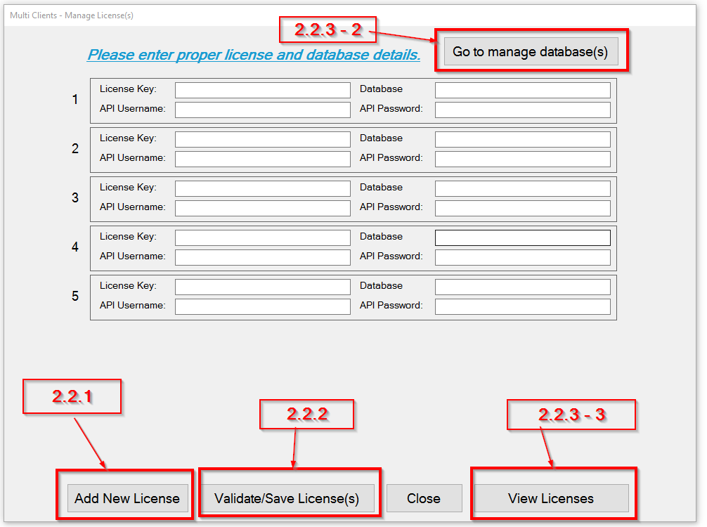

Add New License to create
- User can click on “Add New License” button to add the number of inputs to save licenses.
- Go to Requirement 2.2.2

Save License(s)
- User needs to proper license details License key, API username and API Password from SA web app.
- User need to enter database name in “Database” input to map the department’s POS.
- After entering all clients/departments details properly, user need to click on “Validate/Save License(s)” to save verified license(s) and client/department details in windows registry settings.

Other
- User can close the application by clicking on “Close” button.
- User can go to “Manage Database(s)” page by clicking on “Go to manage database(s)” button (Top right).
- User can go to “View License(s)” page by clicking on “View License(s)” button (Bottom right).

View Licenses Page
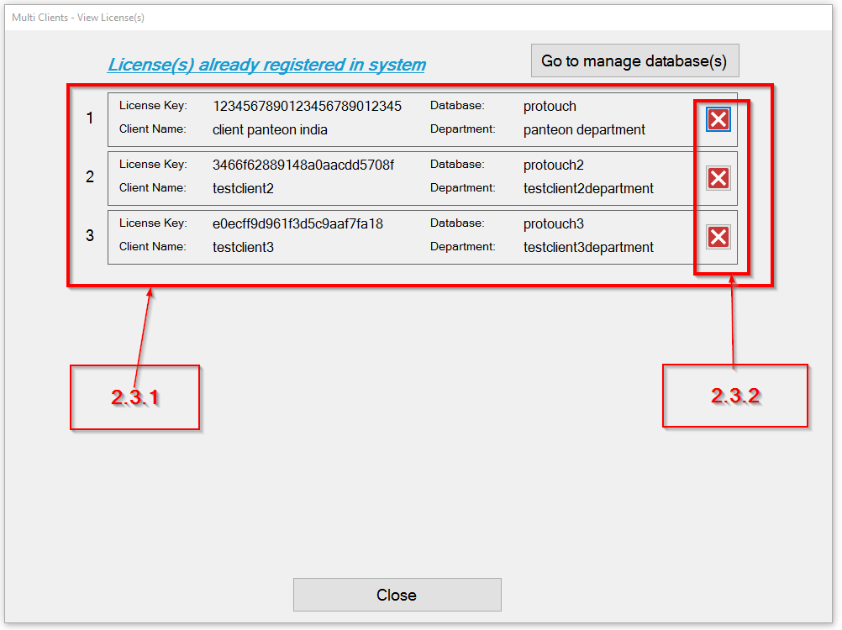
User can go to View Licenses page through “Manage Licenses-> View Licenses”. User can see already registered licenses in View Licenses page.

View already registered licenses
- User can see already registered licenses.

Delete/Remove license from machine registry
- User can delete/remove the license from machine by clicking delete icon in license details row.
- User will be asked the confirmation alert for whether user also want to remove database associated with selected license along with removing license.

End Users related functionality (Client Application)

User Interfaces
- User can see the configured department names list when start the application in multi clients application mode.
  - Department has at least one active user to perform Switch functionality.
- After selecting department name, user need to login in client application (like as normal mode application) when each client starts/switches application first time in a day.
- After first login in a day, user will directly redirected to POS sales screen instead of Menu screen at each switching.
- To switch another client/department, there are two options:
  - Switch Clients menu option
  - Switch Clients button in left top header of POS sales screen next to menu screen.
- After first time login, every time user can see the “Switch Users” screen to switch clients. User can select the username and enter pin code to access system like regular Switch Users functionality.
- If there is only one POS user in system then application will display “Lock Screen” to enter pin code directly instead of select user first.

